**Uber Demand/Supply Gap analysis**

As per analysis demand and supply of cabs varies broadly in evening hours (5pm-8pm) for airport to city rides. Total demand of cabs in evening is approx 1900+ and supply is only approx. 650+ , hence about

1200+ request are not completed.

**Evening hours facts and figures:**

No Cars Available: 1200+ (airport to city) Canceled request: 75+ (airport to city)

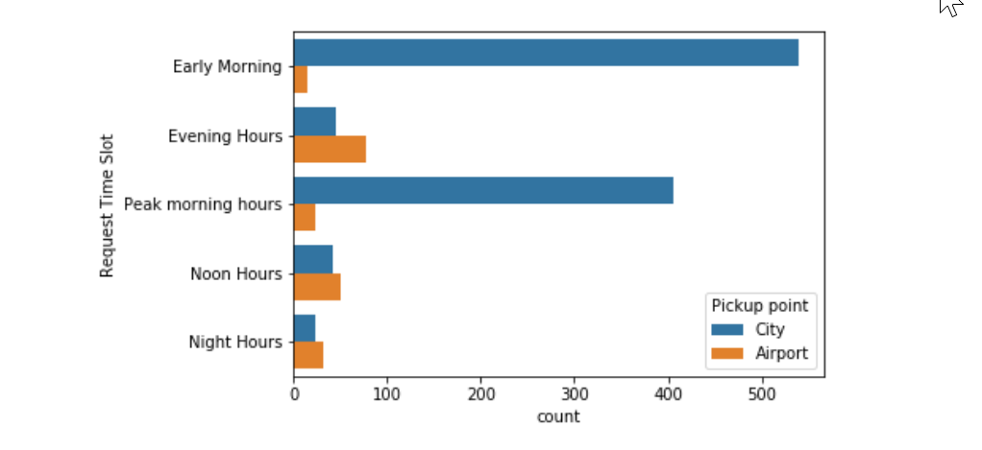 50+ (city to airport) 40+ (city to airport)

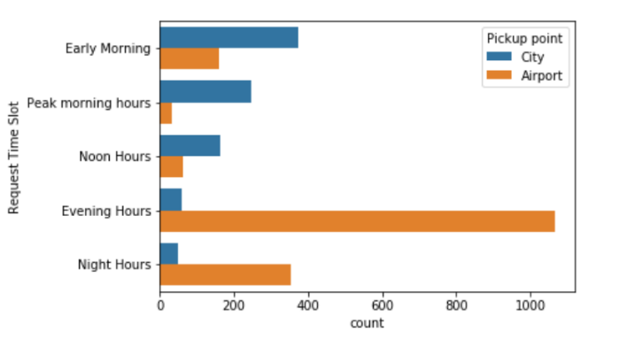

From below plot we can clearly conclude that gap is maximum for airport to city ride in evening hours.

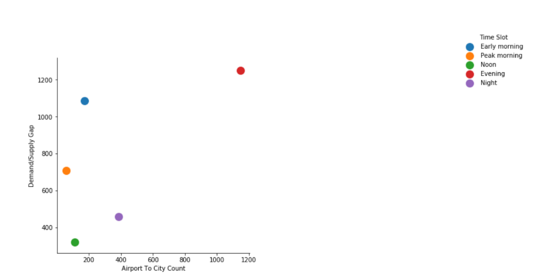

Probable reasons for not meeting this demand:

* Enough no of cars are not available at airport during 5pm-8pm to meet at least 70% of demand.
* More number of cars are assigned for city to airport rides during this slot than required , as we have government buses also available at a good frequency during this duration at cheaper rates , hence drivers remain idle in city for airport rides.

Ways to solve the problem:

* We can reduce the no of cars stationed for city to airport rides during evening hours as we have many other cheaper options available like government buses for airport drops. Transfer these cars for airport to city rides as people prefer door to door cabs from airport rather than buses.
* From below figure we can see that noon hours (12pm-4pm) and night hours (9pm-12pm) are the least busiest time slots when cab request are placed so we try redistribution of cars from these two slots to most busiest time slot i.e evening hours (5pm-8pm) (priority) or peak morning hours (8am-11am).

